**Experiment 10**

**Student Name: Praduman Kumar**

**UID: 20BCS9446**

**Branch: CSE**

**Section/Group: 20 BCS-DM-714-A**

**Subject Name: DATA MINING LAB**

Aim:

Outlier detection using R programming.

**Theory and Output:**

**Outlires**

In R, the IQR() function is used to compute the interquartile range of a given object of numerical values. The interquartile range of these values is a range where 25% on either side is cut off.

Statistically, the interquartile range is the difference between the upper quartile and the lower quartile.

Then, we calculate the interquartile range (IQR) using the IQR() function in R.

The quantile function divides the data into equal halves, in which the median acts as middle and over that the remaining lower part is lower quartile and upper part is upper quartile.

Next, we use the Tukey method to calculate the lower and upper bounds. Any data points that fall below the lower bound or above the upper bound are considered outliers. Finally, we print the lower and upper bounds as well as any identified outliers.

Note that this is just one method for outlier detection and there are many other methods that can be used depending on the specific needs of your analysis.

# **Outlier Program**

data <- c(1, 2, 3, 4, 5, 6, 7, 8, 9, 10, 50)

# Calculate interquartile range IQR<- IQR(data)

# Calculate lower and upper bounds using Tukey method lower bound <- quantile(data, 0.25) - 1.5 * IQR upper bound

<- quantile(data, 0.75) + 1.5 * IQR # Identify outliers

outliers <- data[data < lower bound | data > upper bound] #Print results

cat("Lower bound:", lower bound, "\n") cat("Upper bound:", upper bound, "\n") cat("Outliers:", outliers, "\n")

# **Create** a vector **of random data**

data <- rnorm(100, mean = 50, sd = 10)

# Calculate the quartiles and interquartile range q1 <- quantile(data, 0.25)

q3 <- quantile(data, 0.75) iqr <- q3 - q1

# Calculate the lower and upper bounds for outliers lower <- q1 - 1.5 * iqr

upper <- q3 + 1.5 * iqr

# # Create a box plot of the data

boxplot(data, main = "Outlier Detection", ylim = c(0, 100), ylab = "Data")

# ab1ine(h = lower, col = "red")

ab1ine(h = upper, col = "red")

# Identify the outliers and plot them as points outliers <- data[data < lower | data > upper]

points(rep(1, length(outliers)), outliers, col = "red", pch = 19)

Output:

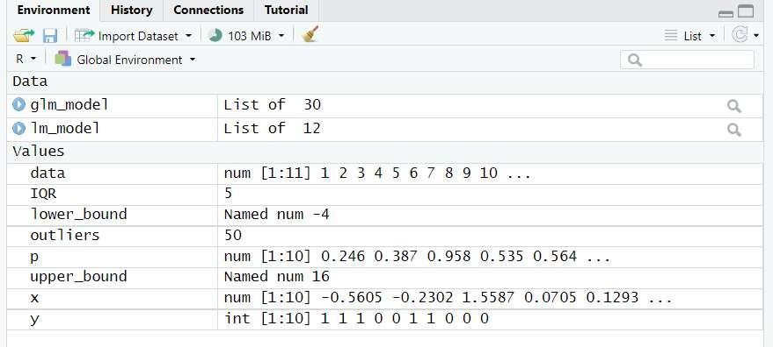

U2IVE£SITT



GRADEA+

Accredited University

0

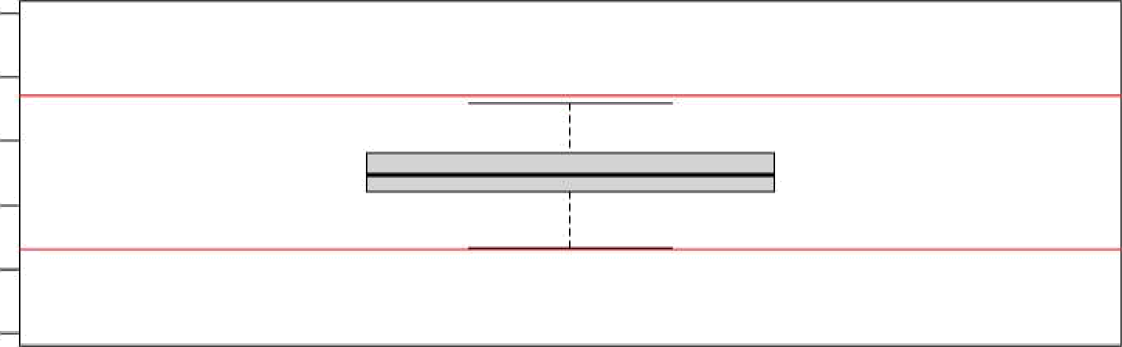Outlier Detection

Data

20 40 60 80